Day 4 - 104608492 - Shirisha Perapagu

Mongodb Aggregations Pipelines Indexes:

1. Created Shopping collection and its 6 documents

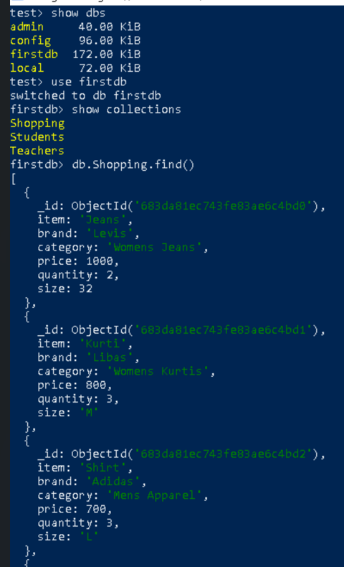 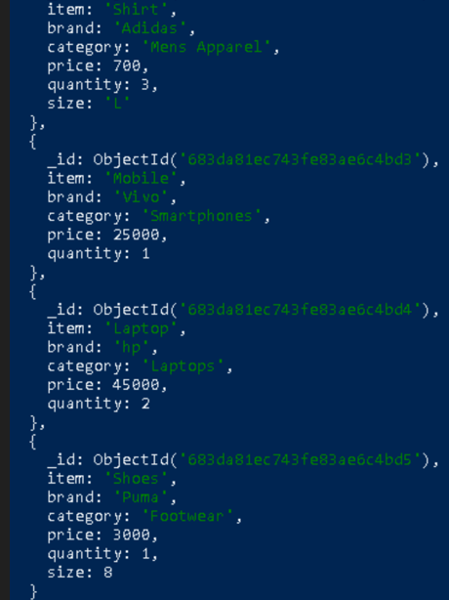

2. **$count** – total no. of items/categories(documents)

**$distinct** – get unique brands

**$group** – totalQuantity by category

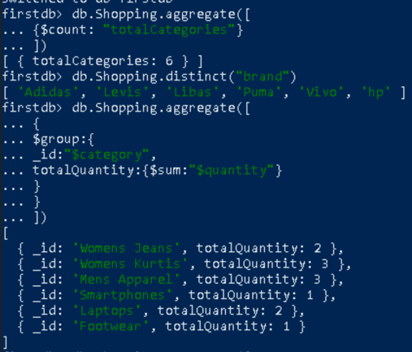

3. **$project** – Calculate totalPrice per item

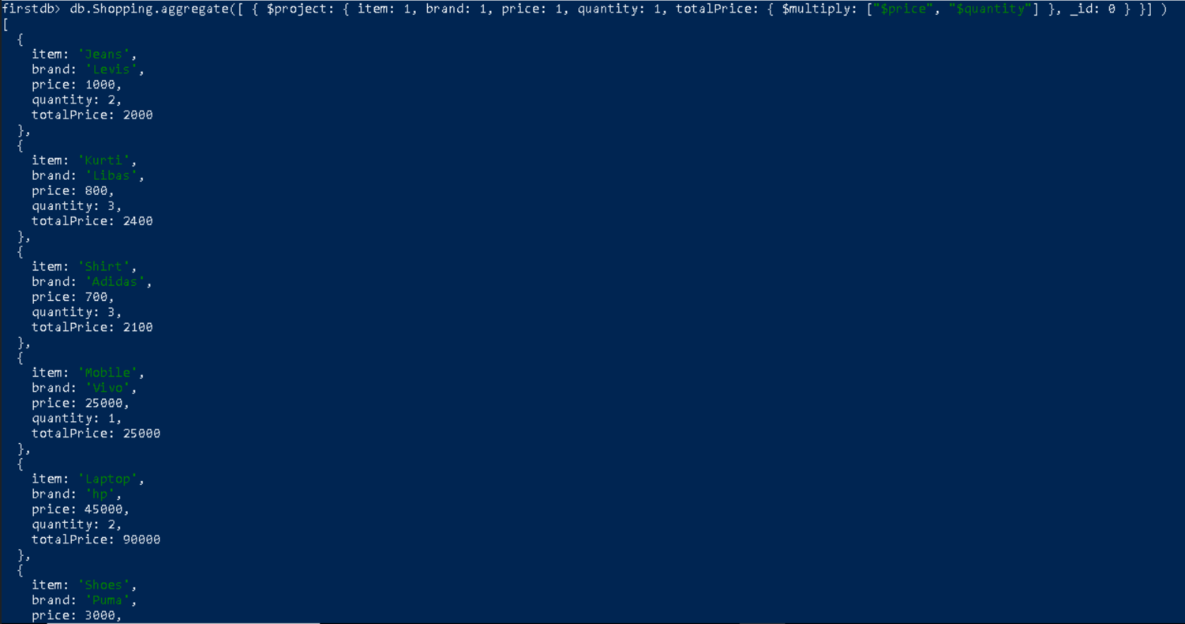

4. **$merge** - stores total price per item into new collection named ShoppingValueSummary

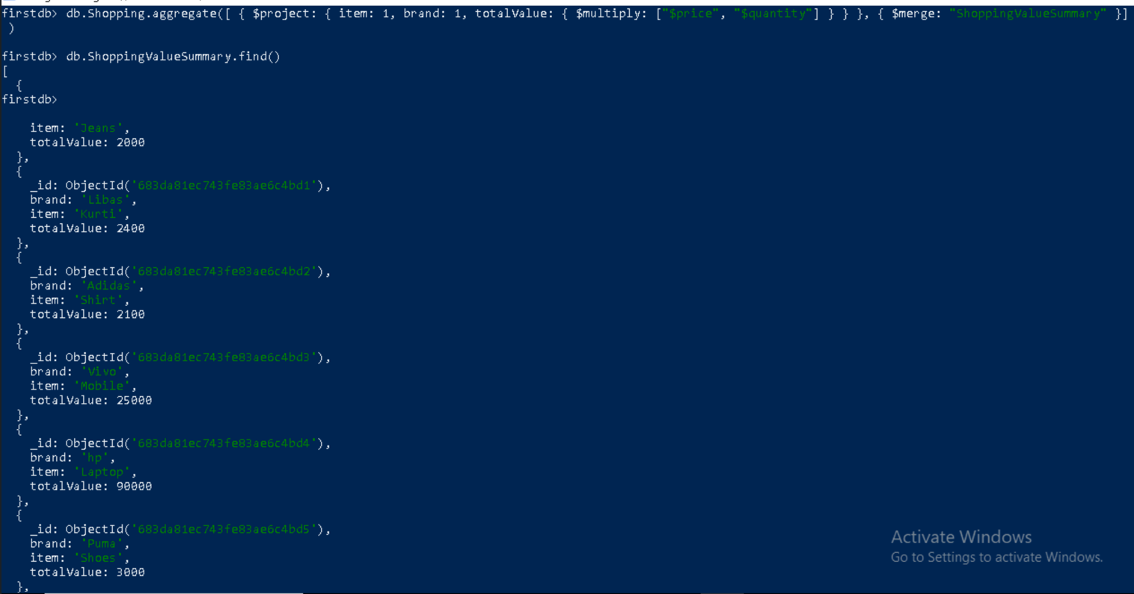

4. **$match** – find all items in the “Womens” category using **regex.**

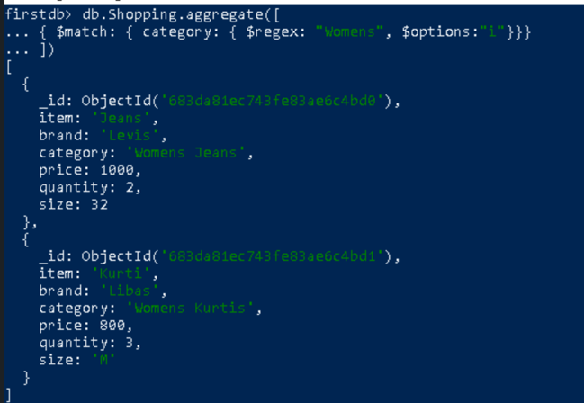

**5. $sort** the price in increasing orderand **$limit** to 3 items

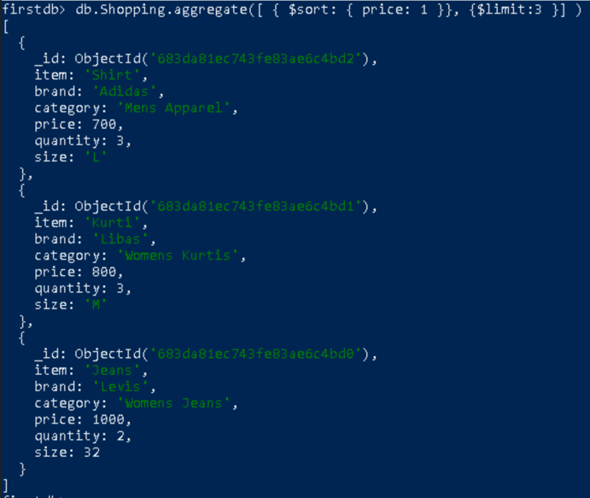

6. **upsert –** appened new item Watch, so now total documents is 7.

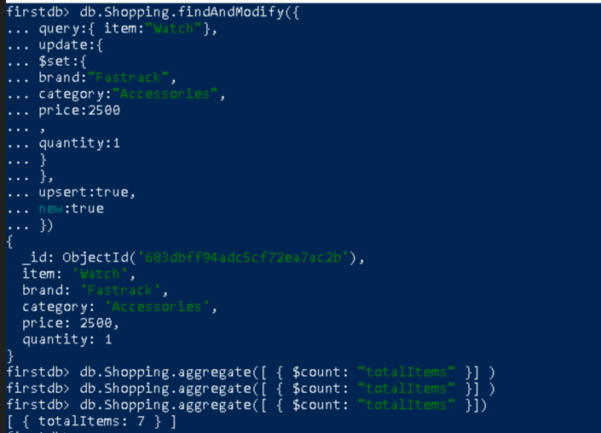

Creating a Text index on category and search with “Womens” word

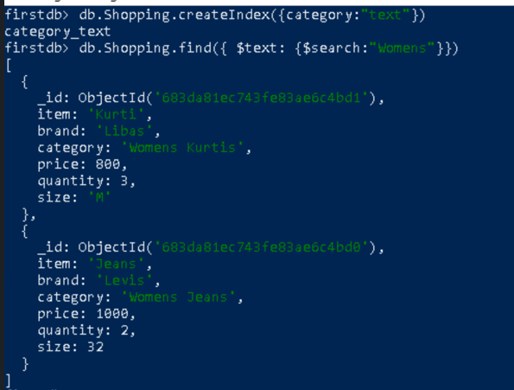

Creating an index on the price field



List all indexes

